TECHNICAL SHEET

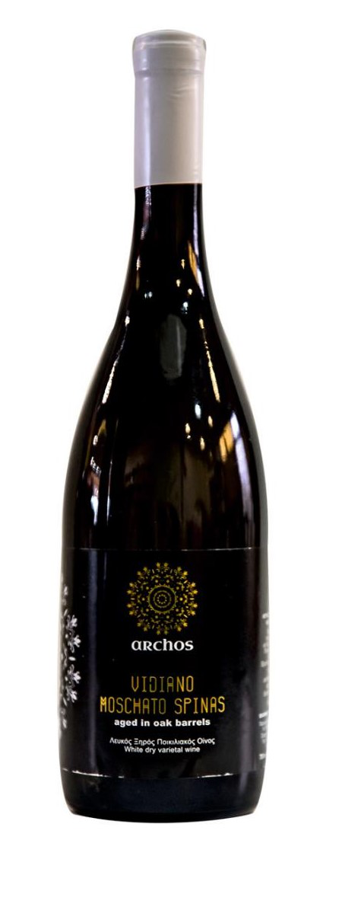
LABEL | ARCHOS
VARIETIES | 50% VIDIANO – 50% MUSCAT OF SPINA
STYLE | DRY WHITE
TERROIR | VINEYARD REGION  KAZOLA PIRGOU HERAKLION,  340m. ALTITUDE, SLOPY, LIMESTONE SOIL, SEMIMOUNTANEOUS WITH GREAT NATURAL DRAINAGE. ORIENTED SOUTH AND WEST
VINIFICATION | SEPARATE FERMENTATION FOR THE 2 VARIETIES  BATTONAGE FOR 1 WEEK ONLY FOR MUSCAT OF SPINA  SEPARATE AGING FOR 4 MONTHS IN NEW FRENCH OAKED BARRELS (500LT EACH)
ABV% | 14%

