TECHNICAL SHEET

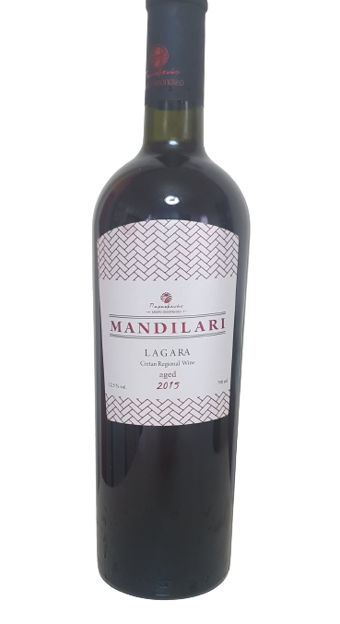
LABEL | MANDILARI LAGARA
VINTAGE | 2015
STYLE | DRY RED P.G.I CRETE
TERROIR | VINEYARD REGION  PLATI PERAMA KROUSONA  (8 ACRES OF VINES, ORIENTED EAST, CLAY SOIL AND HIGH LEVELS OF NATURAL DRAINAGE
VINIFICATION | THE WHOLE CLUSTER IS BEING PRESSED,WHILE 3 TIMES A DAY BATTONAGE IS APPLIED,  A WEEK AFTER FERMENTATION, MATURATION FOR (12) MONTHS IN 3RD USE OF OAK BARRELS.
ABV% | 12,5%

