TECHNICAL SHEET

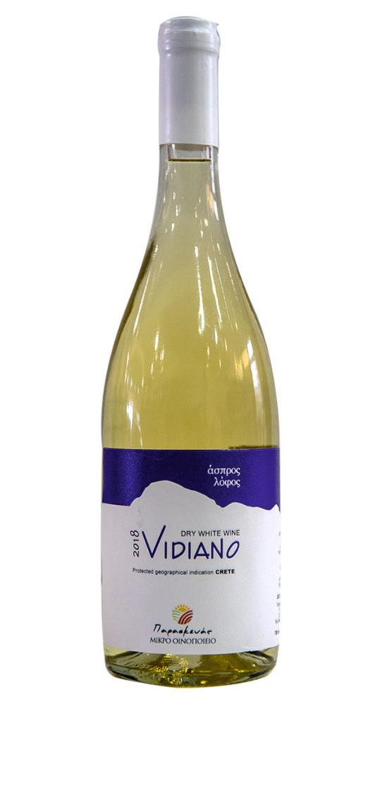
LABEL | ASPROS LOFOS
VARIETIES | VIDIANO
STYLE | DRY WHITE P.G.I CRETE
TERROIR | VINEYARD REGION  KAZOLA PIRGOU HERAKLION,  2 DIFFERENT VINE BLOCKS  340m. ALTITUDE, SLOPY, LIMESTONE SOIL, SEMIMOUNTANEOUS WITH GREAT NATURAL DRAINAGE. ORIENTED SOUTH AND WEST
VINIFICATION | 1 WEEK WITH THE FINE LEES IN OUR SMALL INOX TANKS (2.000 lt EACH).  MATURATION IN INOX TANKS
ABV% | 13%

