TECHNICAL SHEET
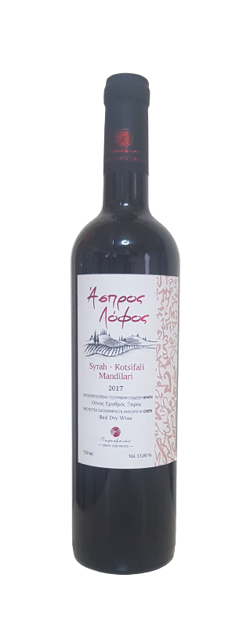
LABEL | ASPROS LOFOS
VARIETIES | 40% SYRAH – 30% KOTSIFALI – 30%  MANDILARI
STYLE | DRY RED P.G.I CRETE
VINTAGE | 2017
TERROIR | MANDILARI VINES:  PLATI PERAMA KROUSONA  (8 ACRES OF VINES, ORIENTED EAST, CLAY SOIL AND HIGH LEVELS OF NATURAL DRAINAGE  SYRAH VINES¨  KAZOLA PIRGOU OF HERAKLION REGION. IN 340m. ALTITUDE ,SLOPY, LIMESTONE SOIL, SEMIMOUNTANEOUS WITH GREAT NATURAL DRAINAGE. ORIENTED SOUTH AND WEST  KOTSIFALI VINES:  MALEVIZI, DIFFERENT BLOCKS OF COLLABORATIVE VITICULTURISTS OF THE REGION
VINIFICATION | SEPARATE FERMENTATION OF EACH VARIETY.  MATURATION/AGING : 6 MONTHS IN 2ND USE OF FRENCH OAK BARRIQUES.
ABV% | 13%

