TECHNICAL SHEET
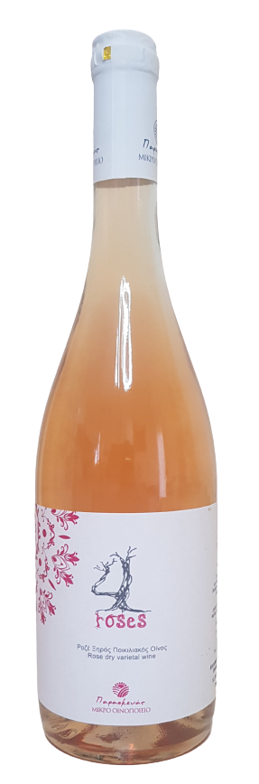

LABEL | 4 ROSES
VARIETIES | LIATIKO, KOTSIFALI, MANDILARI, SYRAH
STYLE | ROSE DRY
TERROIR | SARHOS REGION, DIFFERENT BLOCKS OF COLLABORATIVE VITICULTURISTS OF THE REGION
VINIFICATION | EACH VARIETY HAS BEEN FERMENTED SEPARATELY  MATURATION IN INOX TANKS
ABV% | 12%

