ΤΕΧΝΙΚΑ ΧΑΡΑΚΤΗΡΙΣΤΙΚΑ
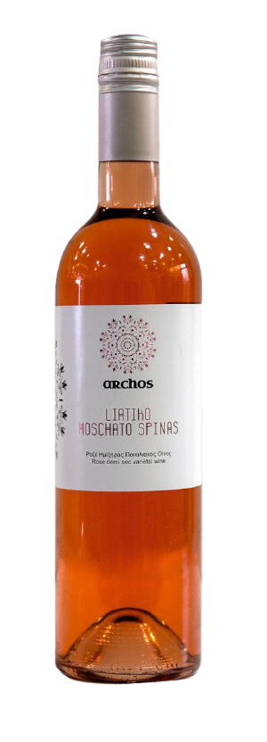

LABEL | ARCHOS
VARIETIES | 70% LIATIKO- 30% MUSCAT OF SPINA
STYLE | SEMI DRY ROSE
TERROIR | VINE REGION OF MALEVIZI (PRINIA, MARATHOS, SARHO), IN COLLABORATION WITH FARMERS OF THE REGION.
VINIFICATION | SEPARATE FERMENTATION FOR LIATIKO AND MUSCAT OF SPINA. PREMIUM SELECTION OF FULLY MATURED LIATIKO GRAPES.  MATURATION IN INOX TANKS
ABV% | 12%

